EXPERIMENT NO : 06

Title
To deploy a simple Flask-based web application using Google App Engine Launcher (GAE Launcher).

Theory
Google App Engine (GAE) is a cloud-based Platform-as-a-Service (PaaS) provided by Google Cloud that enables developers to build and host web applications without managing the underlying infrastructure. It automatically handles scaling, monitoring, and load balancing. The older version of GAE provided a graphical interface called Google App Engine Launcher for local testing and deployment.
Flask is a lightweight Python framework used for creating web applications. It provides routing, request handling, and template rendering features, making it ideal for small projects and cloud-based deployments.
Key features of Google App Engine:
• Automatic scaling of applications.
• Support for multiple languages (Python, Java, Go, PHP).
• Integrated SDK and local development tools.
• Easy deployment through Launcher or gcloud CLI.

Procedure
The steps followed to deploy the Flask app using Google App Engine Launcher are as follows:
- Installed Python 3.x from the official website (https://www.python.org/downloads/).

- Installed Google App Engine SDK for Python (which includes GAE Launcher).
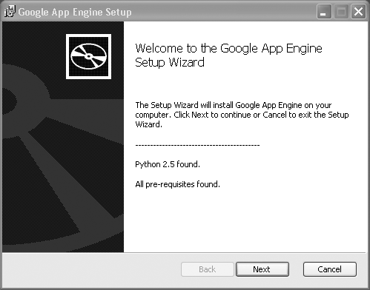

- Created a new project folder named ‘GAE_FlaskApp’.

- Inside this folder, created a Python file named main.py with the following code:

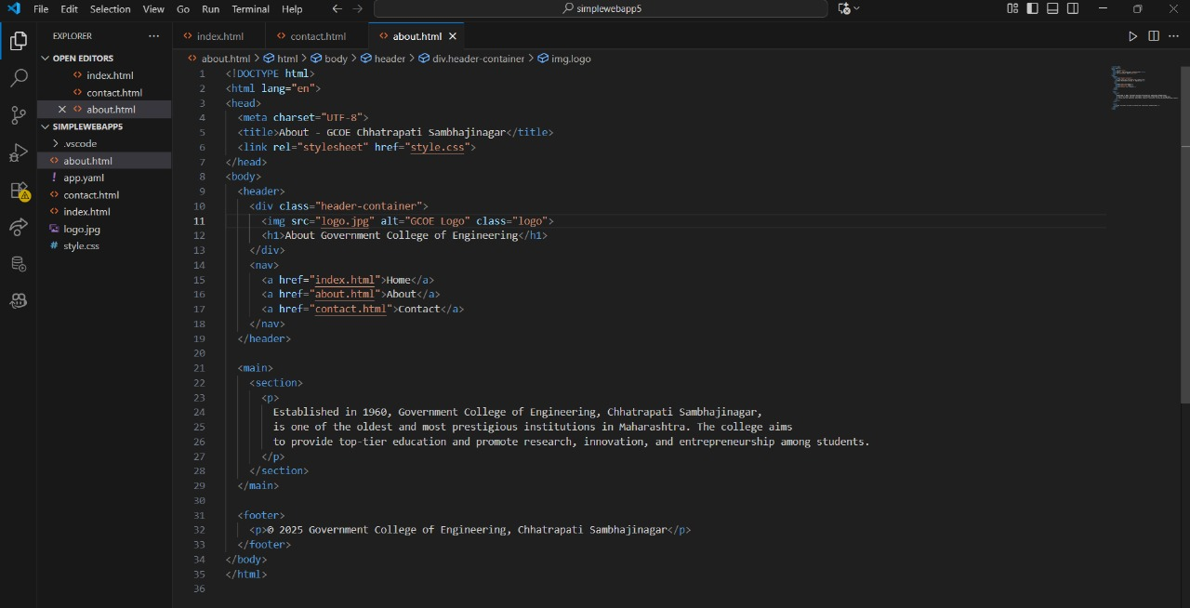
Screenshot of code

5. Opened Google App Engine Launcher from Start Menu.

6. Clicked on ‘File → Add Existing Application’ and selected the Flask project folder.

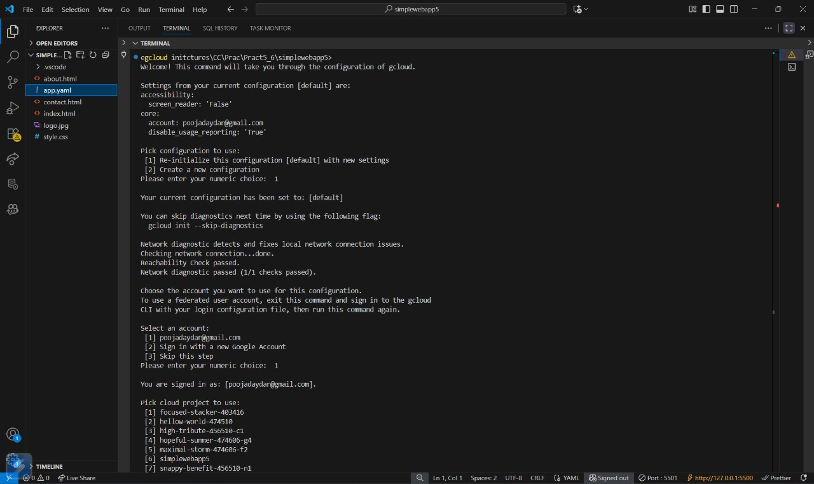

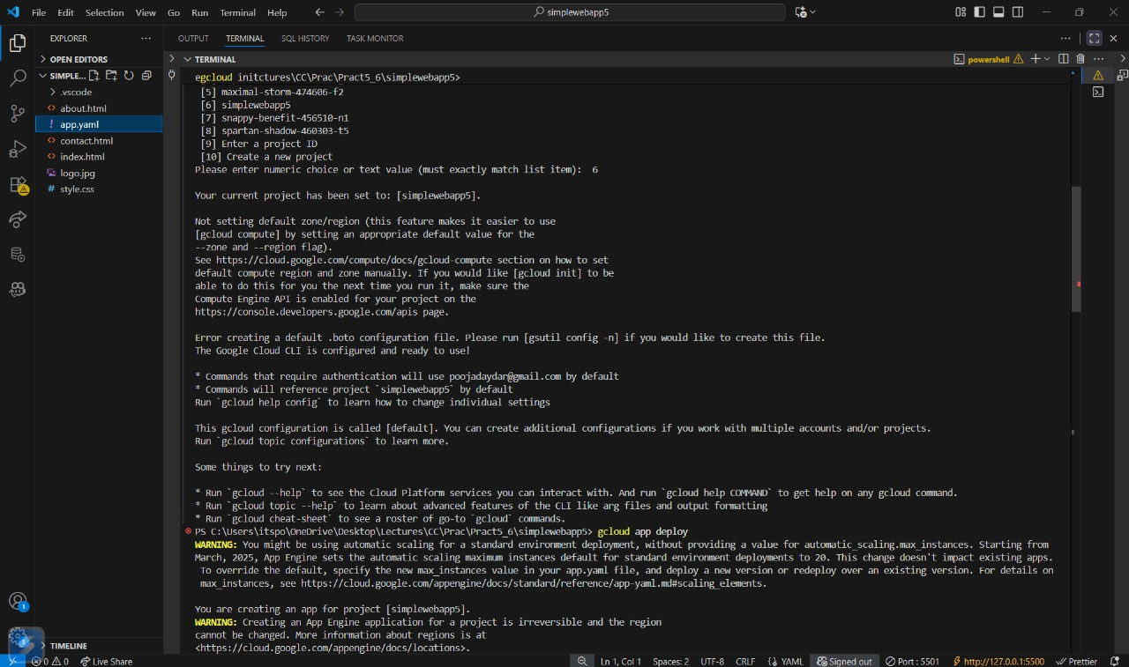
GAE Launch

7. Clicked the ‘Run’ button to start the local server.

8. Opened a web browser and navigated to http://localhost:8080 to view the app output.

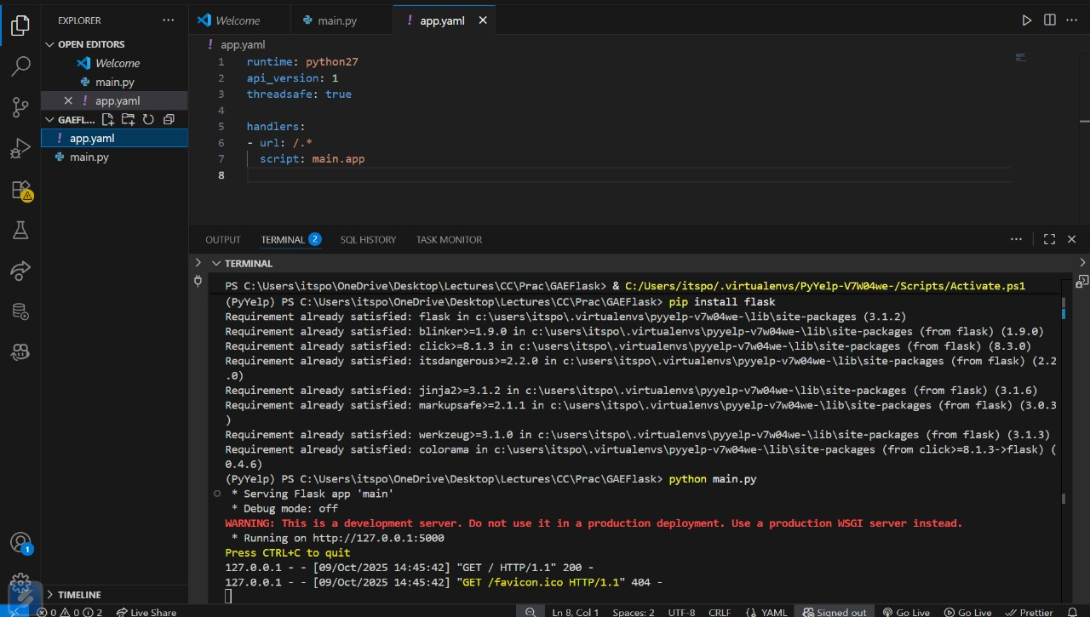
Local Host IP

Output / Result

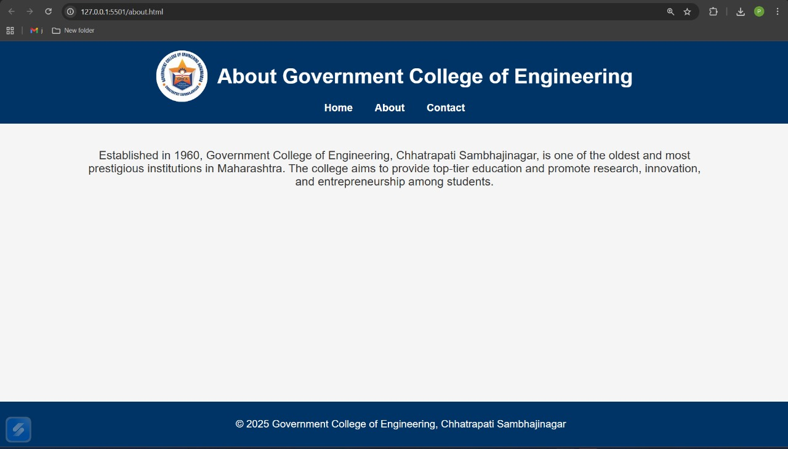
Output on Browser

Conclusion
A Flask-based Python web application was successfully created and deployed locally using the Google App Engine Launcher. This practical demonstrates how to configure and run Flask web applications using GAE’s legacy local environment.

